**Fixed Gain Transimpedance Amplifier (TIA) for Two-Photon Microscopy**



**Work Report**

**Supervisor: Prof. Peter Torok**

**Acknowledgement**

The final outcome and success of this project would not have been possible without the expertise and patience of the collaborators involved.

NOBIC would like to thank OneThesis for their expert work in the design, verification and adjustments of the circuit. Special thanks to the Principal Consultant Kenneth for his dedication to the project.

**Disclaimer**

The work documented in this report reflects work done between NOBIC lab and Thesis Pte Ltd (OneThesis). Parties involved have made a best effort to design a circuit that meets the requirements listed in the design specifications, specifically for the lab’s use cases in two-photon microscopy.

It is the responsibility of the end user to verify proper and reliable operation in the actual application. Modifications to documented design including component substitution and printed circuit board layout may significantly affect circuit performance or reliability. Contact NOBIC lab and/or OneThesis for assistance.

**NOBIC Transimpedance Amplifier (TIA)**

**Objective**

Design and fabricate a transimpedance amplifier (TIA) for use in two-photon microscopy with a small physical area in order to keep the distance between the final circuit and detector as small as possible. This aims to keep the detector output cable as short as possible to preserve the expected small output current (uA) of the detector from environmental noise.

Electrical specifications for the TIA are referenced from a Femto DHPCA-100 preamplifier as a base. Typical use settings for the Femto preamplifier (preamp) are;

* 104 V/A gain
* 10MHz bandwidth limited
* 1.8pA/√Hz input noise density
* DC coupled

The designed circuit needs to be of equal or better specifications than the Femto preamp, especially for noise. Further, the dimensions are to be as small as possible so as to fit into a custom built microscope assembly with the detector and preamp circuit being as close to each other as possible.

**Simulation**

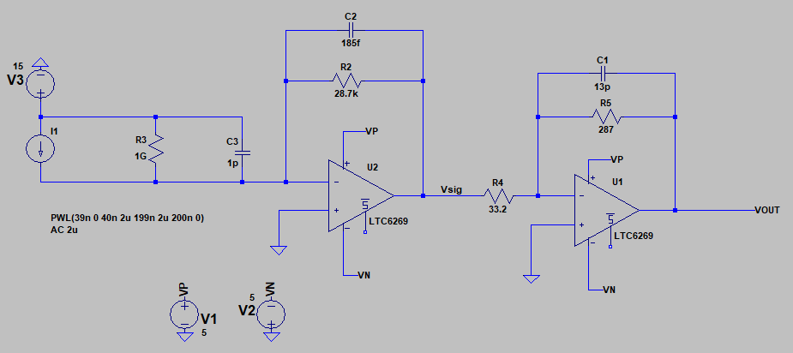

Figure 1. LTSpice simulation of TIA circuit

Simulation was conducted in LTSpice with LTC6269 operational amplifiers (opamps) [[Analog Devices](https://www.analog.com/en/products/ltc6269.html)] with an overall gain of 248kV/A (detector 2uA input signal amplified to 496mV output).

Feedback capacitors of 185fF for 1st stage and 13pF for 2nd stage, results in an upper cutoff frequency of ~23MHz. Simulated input noise density shows ~800 fA/√Hz at 1MHz.

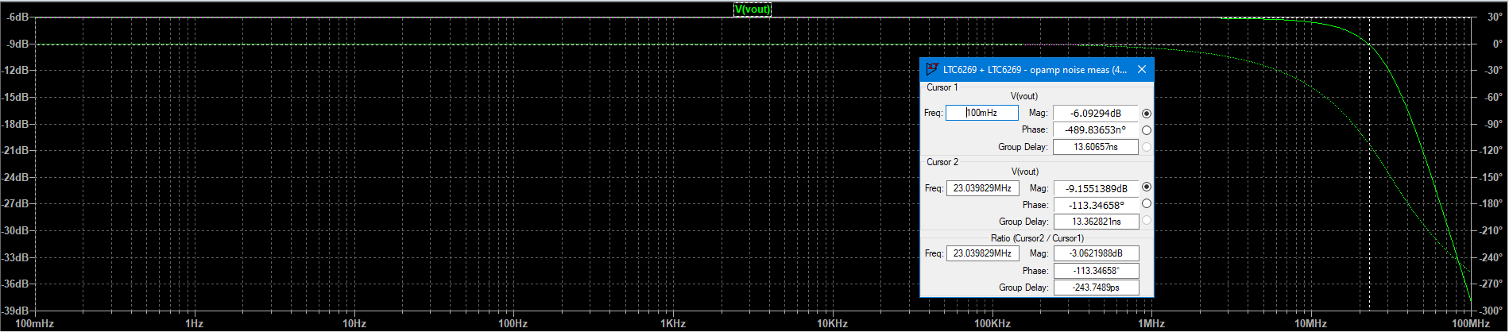

Figure 2. -3dB upper cutoff frequency of ~23MHz

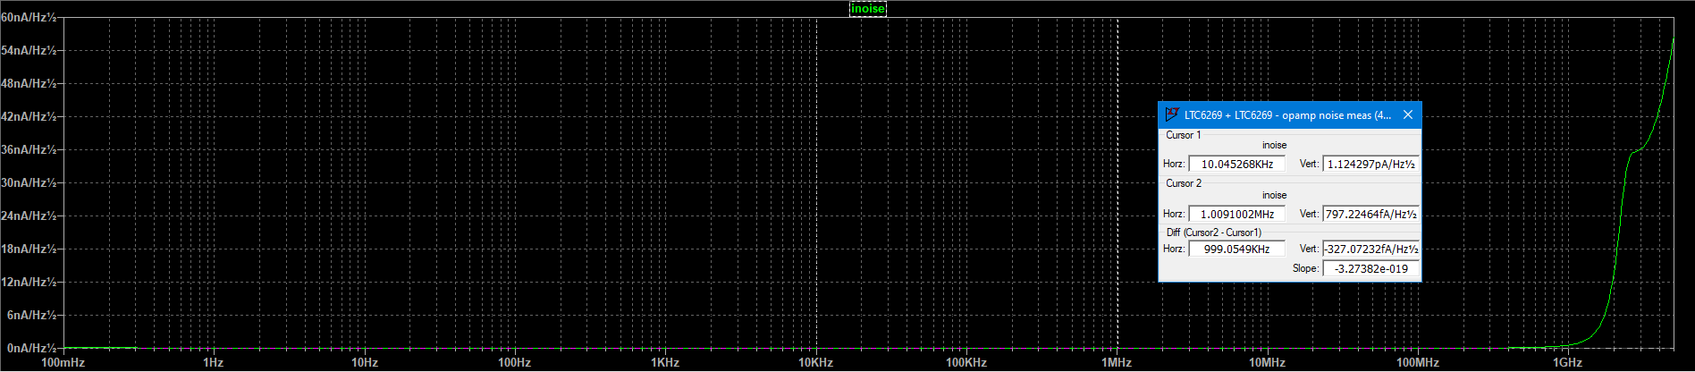

Figure 3. Input noise density of 797fA/√Hz at 1MHz

**Final Printed Circuit Board**

After several component iterations, the feedback capacitor for 1st stage has been changed to 0.75pF, with gain resistors unchanged. The final iteration of the designed TIA printed circuit board resulted in the following parameters:

* 250k V/A gain
* 11MHz bandwidth

Input noise density was assumed to closely follow that of simulations, due to inability to verify the expected fA scale noise density in actual measurements.

Testing of printed circuit board was conducted using an oscilloscope as the measurement device. The test signal was generated with a function generator by placing a 200kΩ resistor in series with the input to the TIA and Femto to generate a 2uA current at 400mV sine wave input. The results are shown in the figures in the following pages.

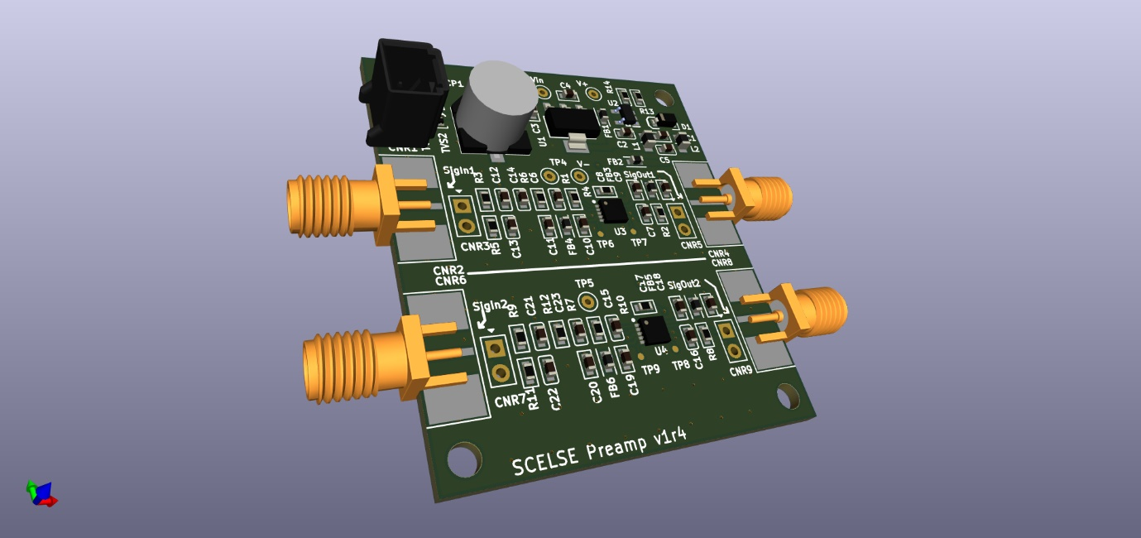

Figure 4. 3D mockup of final Preamp printed circuit board

Signal comparison – 2uA 3MHz input – TIA vs Femto

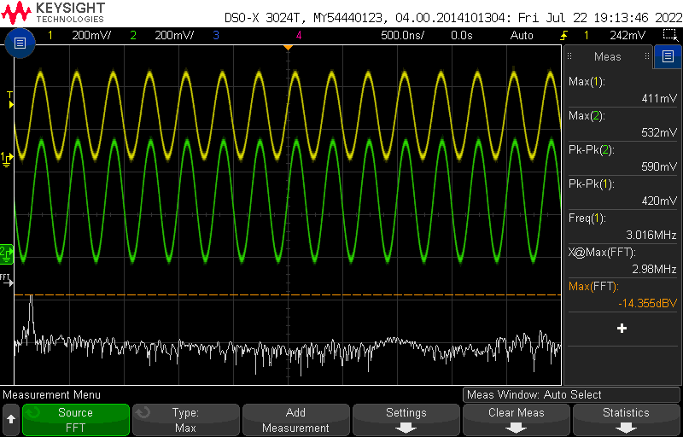

Figure 5. TIA output of 590mVpp with 2uA input signal at 3MHz

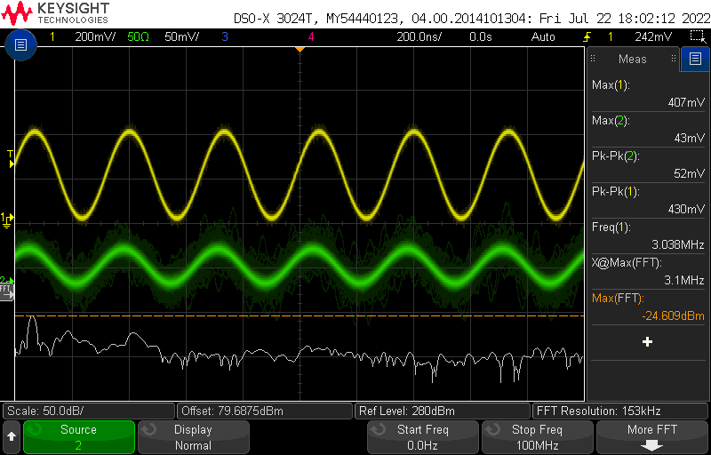

Figure 6. Femto output of 52mVpp with 2uA input signal at 3MHz

Signal comparison – 2uA 10MHz input – TIA vs Femto

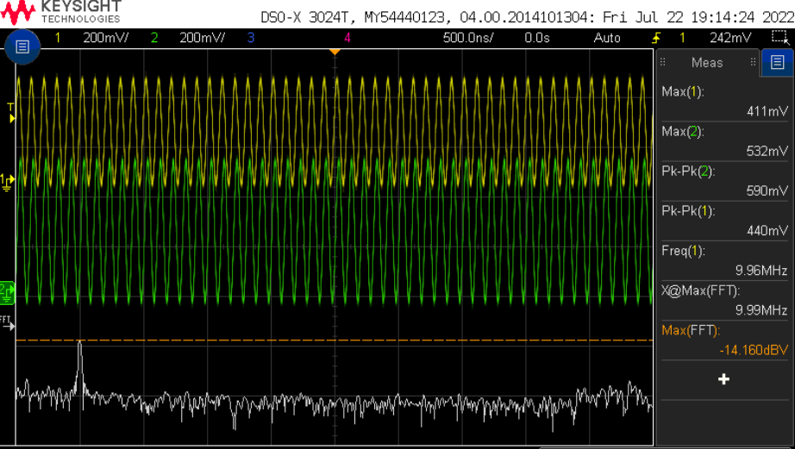

Figure 7. TIA output maintains 590mVpp with 2uA input signal at 10MHz, even frequency response compared to 3MHz.

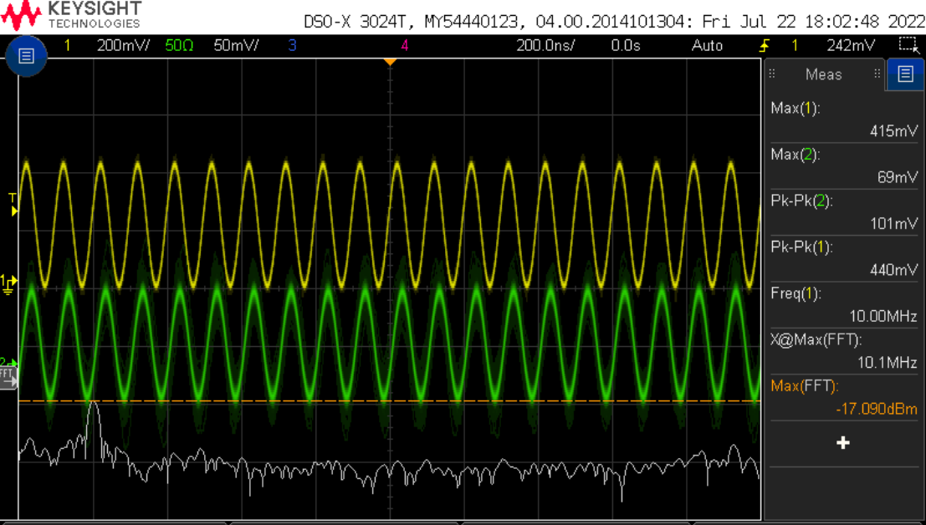

Figure 8. Femto output shows 101mVpp with 2uA input signal at 10MHz, indicates uneven frequency response compared to 3MHz.

**Conclusion**

The designed TIA circuit has met the specified objective of exceeding the Femto DHPCA-100 preamplifier by achieving a signal gain of 250 kV/A while maintaining a bandwidth of 11MHz, compared to 10 kV/A over 10MHz of the DHPCA-100. Based on simulations, the noise performance of the circuit is generally comparable to the Femto preamp. The TIA is also shown to have a more even frequency response across the 11MHz bandwidth compared to the Femto preamp, maintaining the output gain across the bandwidth while the Femto preamp results in a greater change at the tail end of the bandwidth.